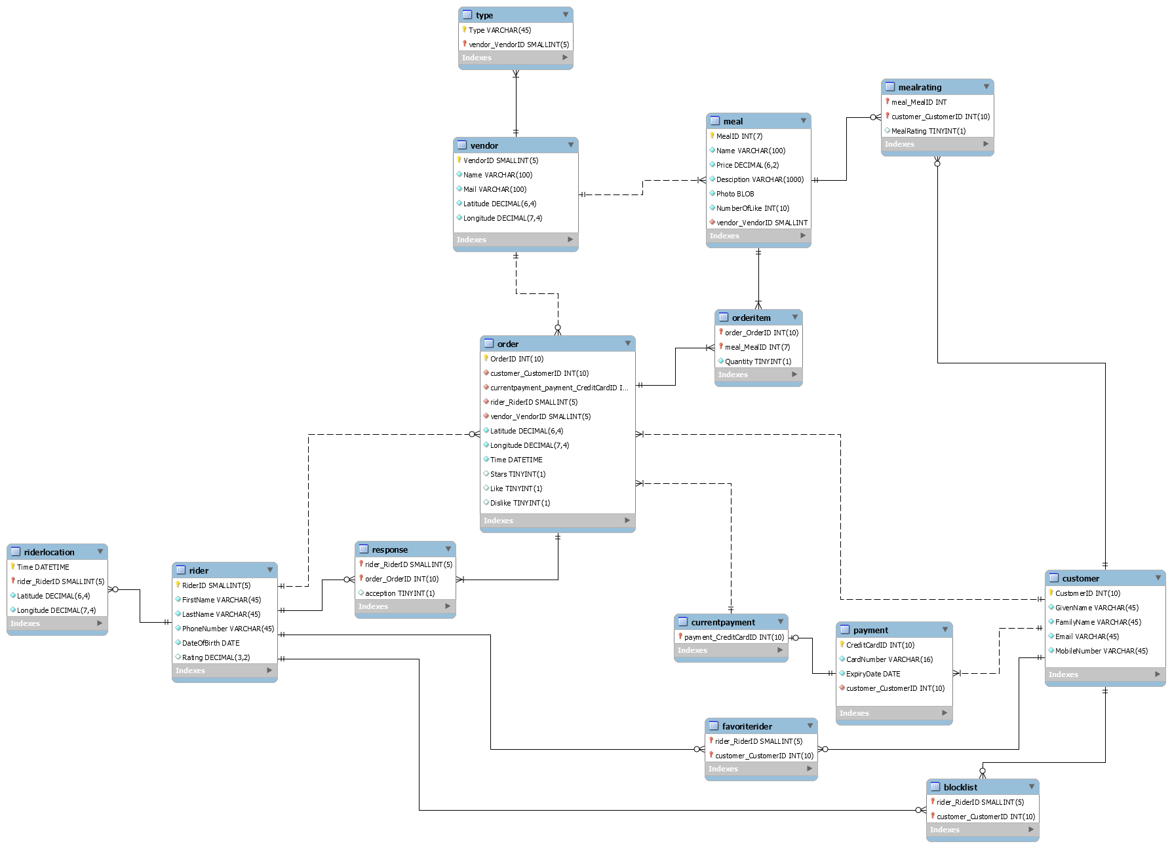

**Assumption:**

1. A customer can have no order after the registration.

2. Rider can have no response to the assigned order, which means they press neither “accept” nor “no thanks”.

3. For each delivery, customer can choose to either rate or not to rate on the rider’s performance.

4. For each delivery, customer can choose to add the rider in “favourite” list or “don’t send again” list, or not.

5. Customer mobile number may contain symbols like bracket, plus, space, etc.

6. There may be some new riders who just registered accounts, so they have no orders.